**Practical No. 7**

**Aim:** To Perform Simple queries, string manipulation operations implement group by having.

**Theory:**

Simple queries involving string manipulation operations, combined with the GROUP BY and HAVING clauses, offer powerful tools for extracting specific data subsets and performing aggregate calculations

**Queries:**

1) List the number of different products supplied by each supplier_no.

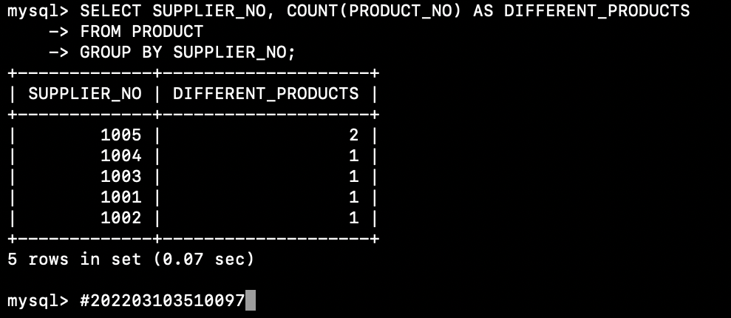

2) List the name of each supplier with the location of each depot and the number of products supplied by that supplier and stocked at that depot.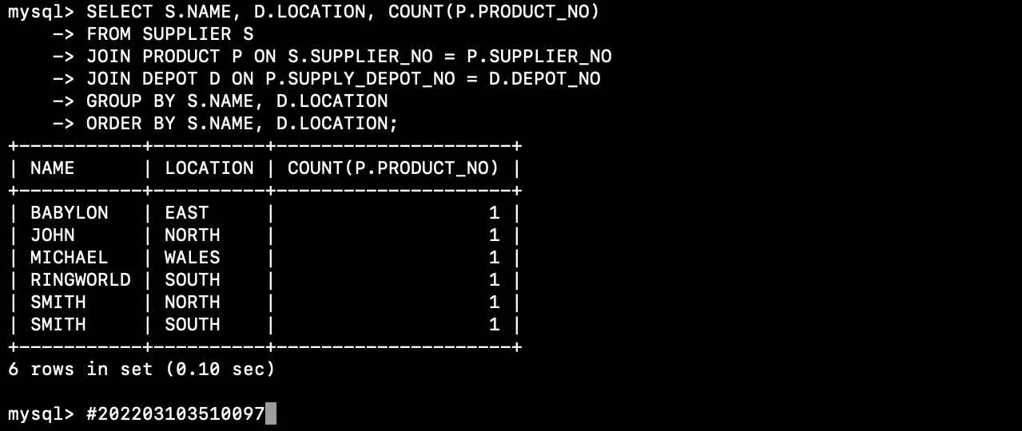

3) List the depot_no’s of all depots where the average credit_limit for all the customers receiving deliveries from the depot is > 20,000.

4) List total no of quantity and product number ordered by customer.



5) Give product number which has maximum quantity stock at any depot.



6) Give customer address which has minimum credit limit.



7) List supplier no who has supplied products whose total price is > 1000.

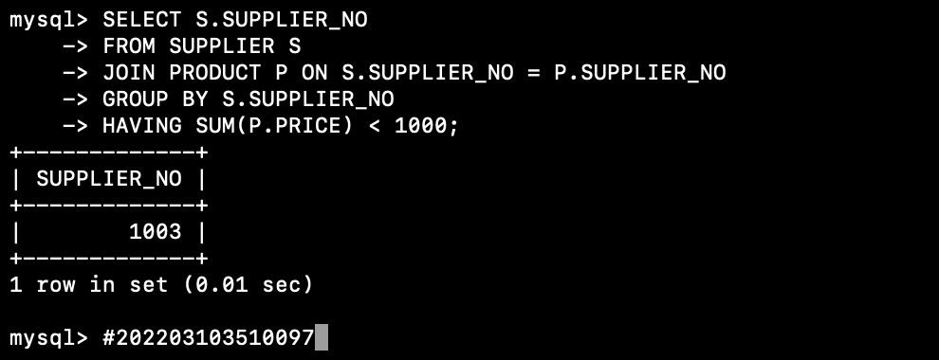

8) Give total number of customers who has ordered product on same date.



9) List sum of quantity stocked at each rack.



10) Display total no of customers who has received product from same location.

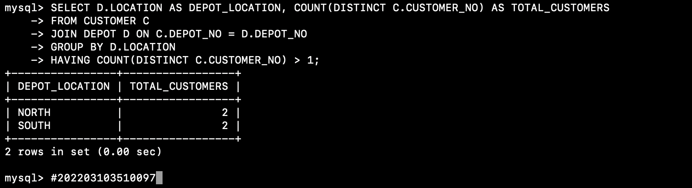

**Conclusion:** Leveraging simple queries, string manipulation operations, and the GROUP BY and HAVING clauses in SQL empowers data analysts and database administrators to perform more complex and targeted data extractions and analyses. By combining these techniques, organizations can gain valuable insights into their data, leading to better decision-making and improved data-driven strategies. Understanding the synergy between these SQL components is a crucial skill for anyone working with relational databases.